1. Install Git

Search for Git download. Select *Git-Downloads – Git SCM* link

During the install, take the defaults, EXCEPT for this.  Watch for it during install. This is what you want it to look like before continuing:

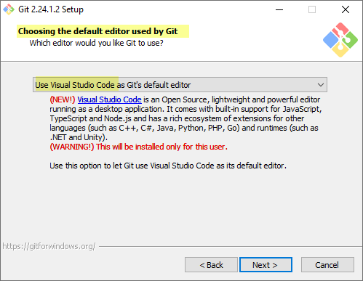

1. Install Kdiff

Search for kdiff3 download

Click on Download and take all defaults

1. Install Git Extensions

Search for Git Extensions download

Click on Download and take all defaults

1. Create Git Hub Account – Make sure to record your credentials in your google drive file and don’t lose them.  For my username I was able to use KimLClark.

Go to <https://github.com/> and create an account for yourself.  If they ask you to create a repo, call it “EbayTracker”.

1. Clone a Repo from the server.
   1. On Git Hub:  
      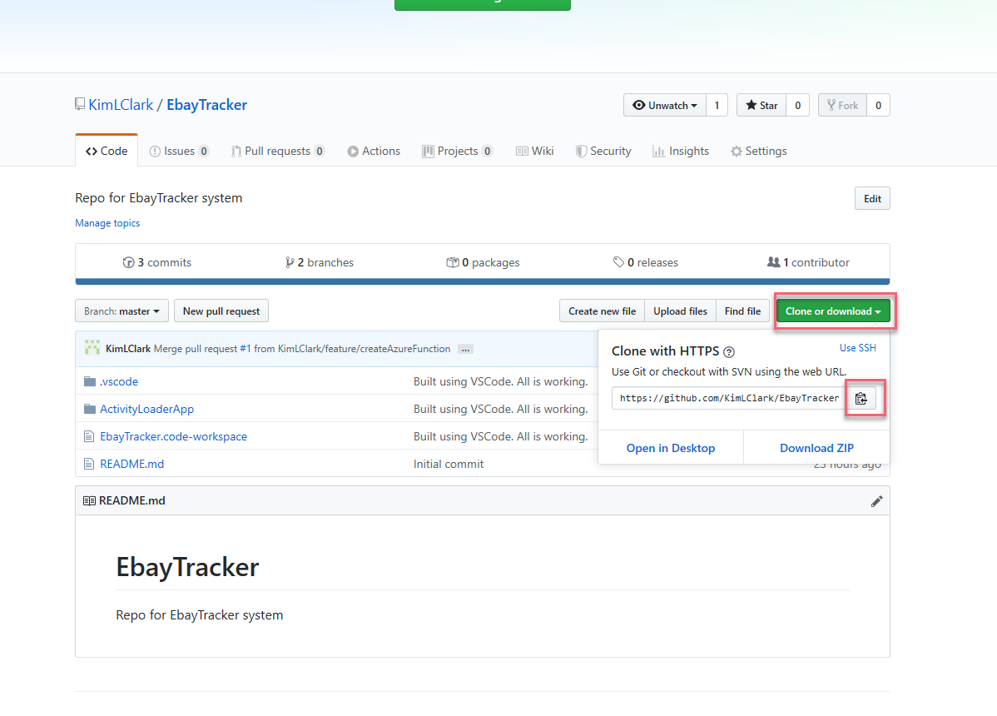
   2. In Git Extensions  
      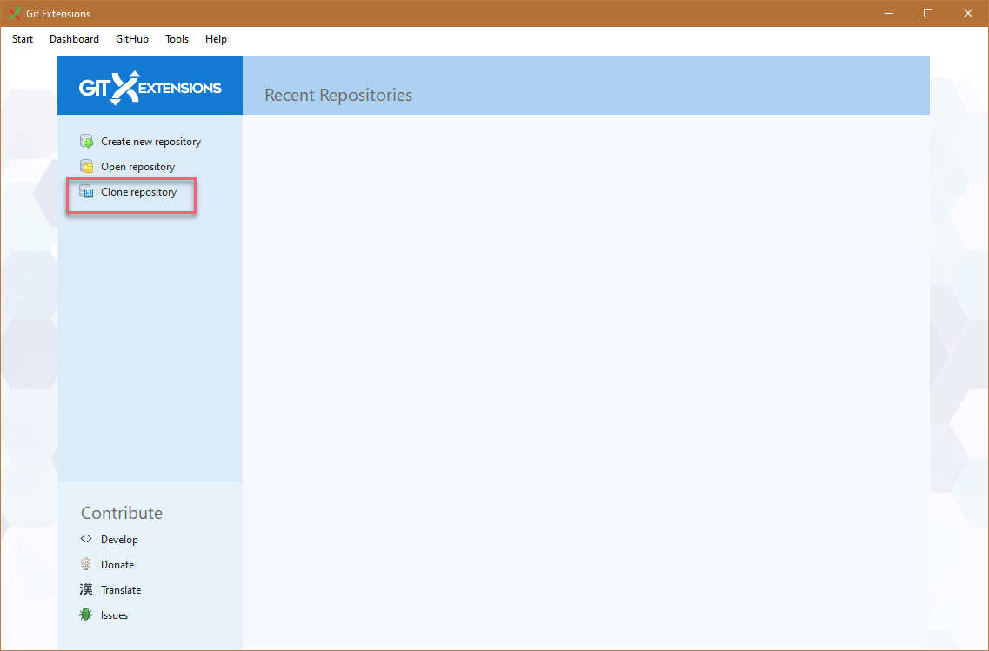
   3. 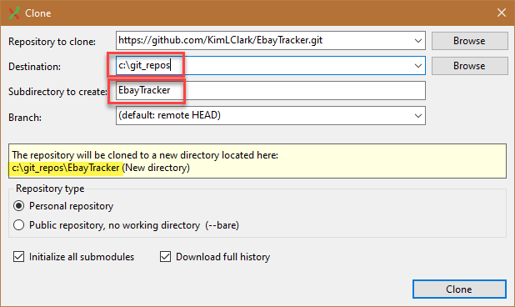
   4. C:\git_repos\EbayTracker will be the root of your repo which is the root of your code.